**HOD401 -** 234567

**Nguyen Cong Thanh**

**SE130443**

**IA1301**

**Module 4 : Enumeration**

**Lab 2: Enumerating Network Resources Using Advanced IP Scanner**

Scanning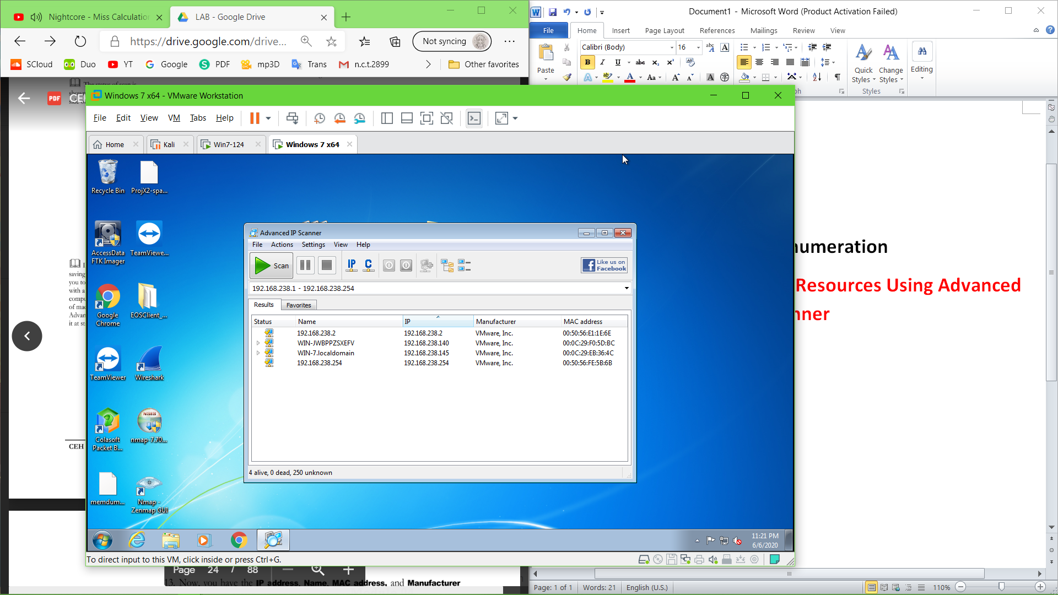

Expan services

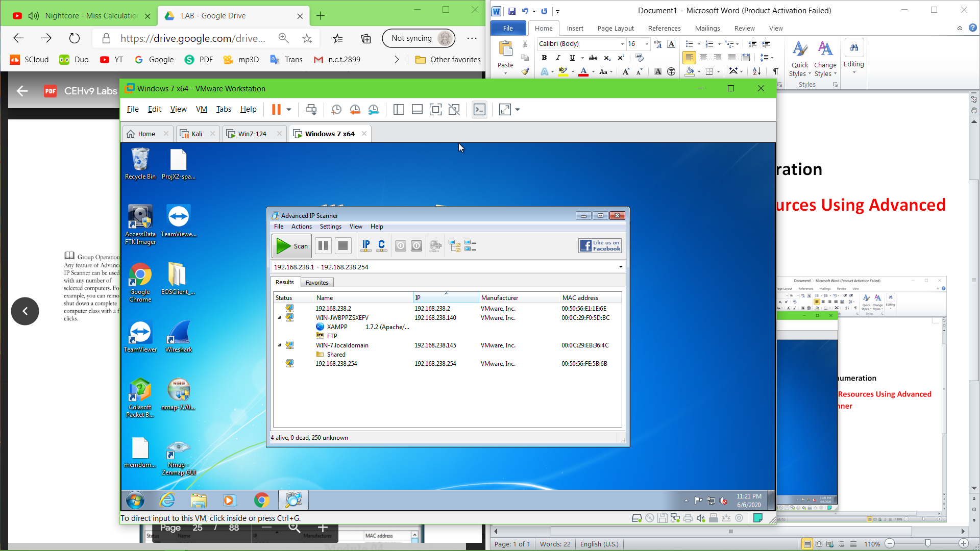

Shutdown 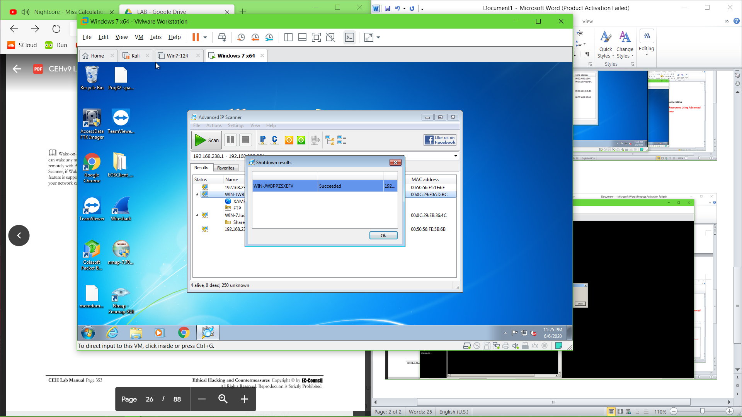

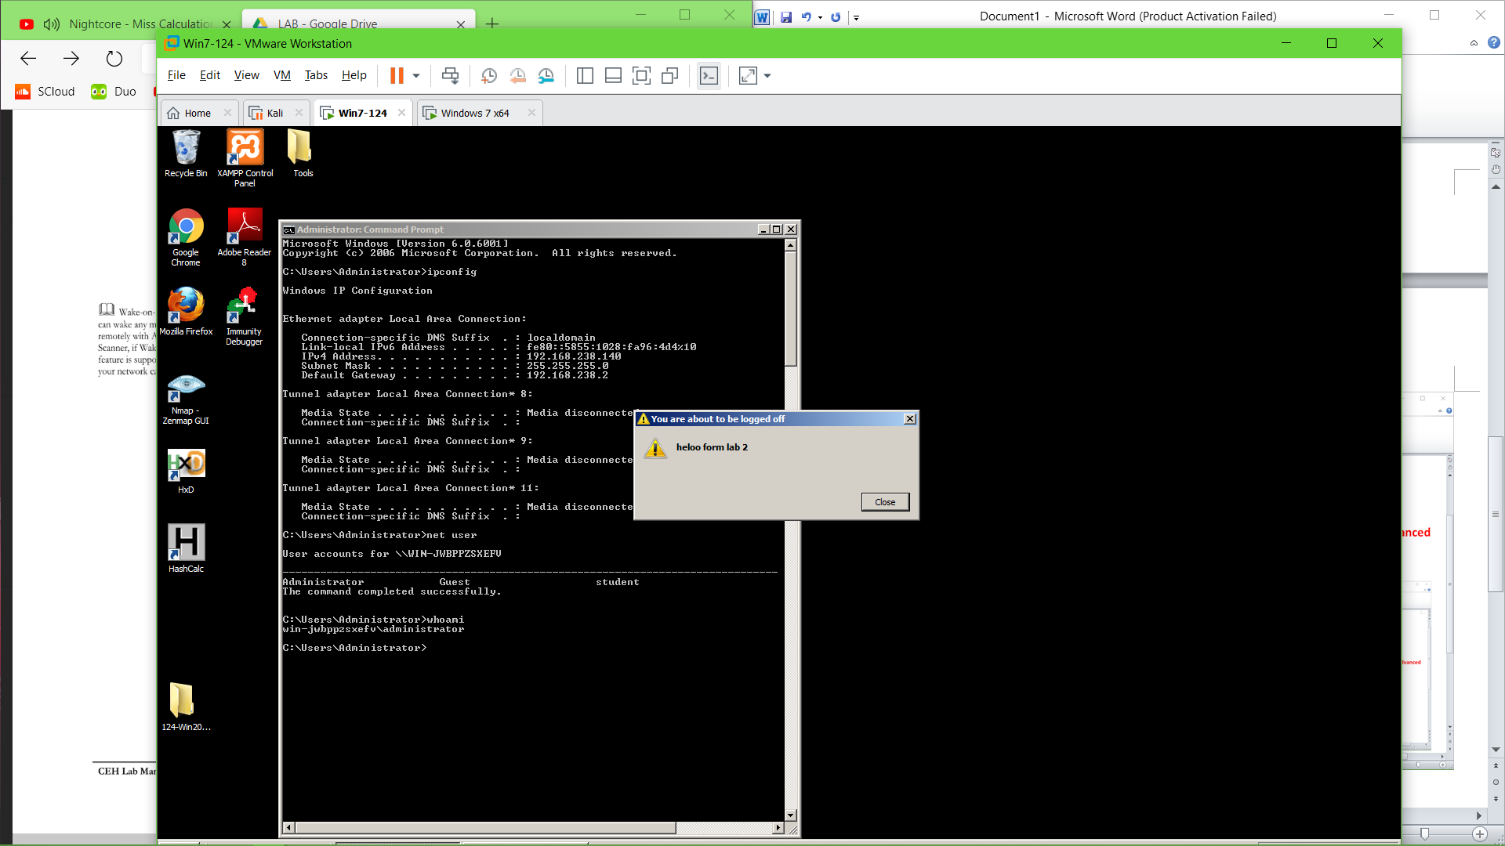

**Lab 3: Performing Network Enumeration Using SuperScan**

**Running**

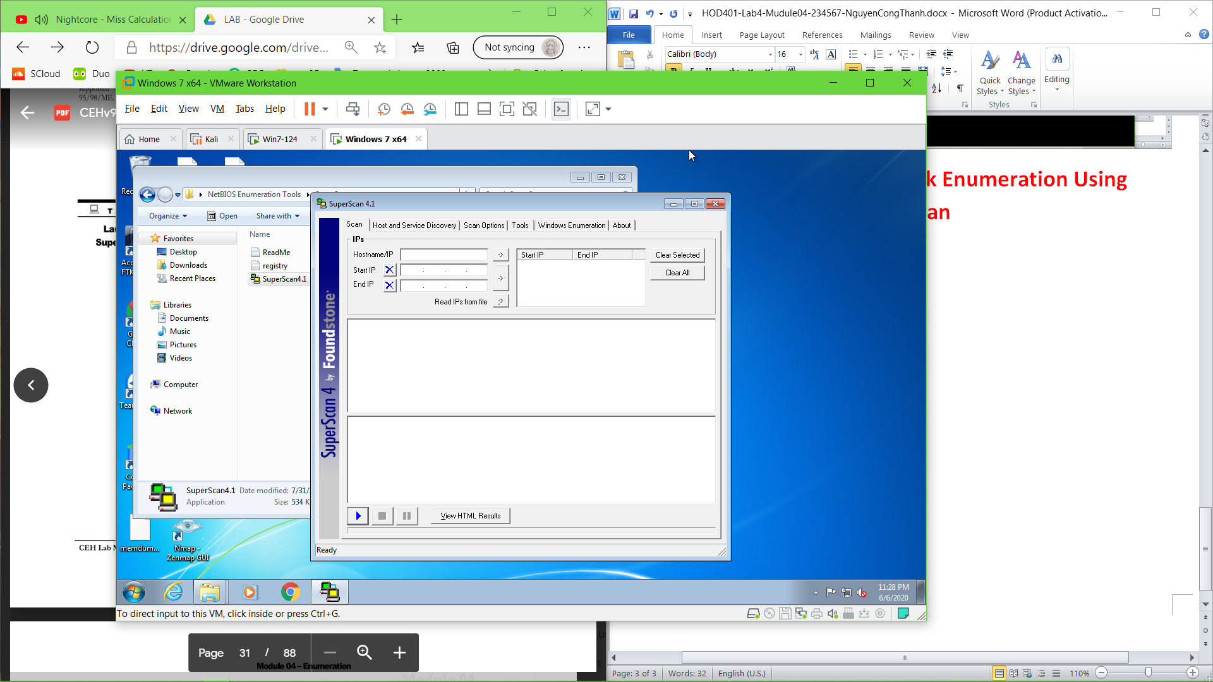

**Enum** 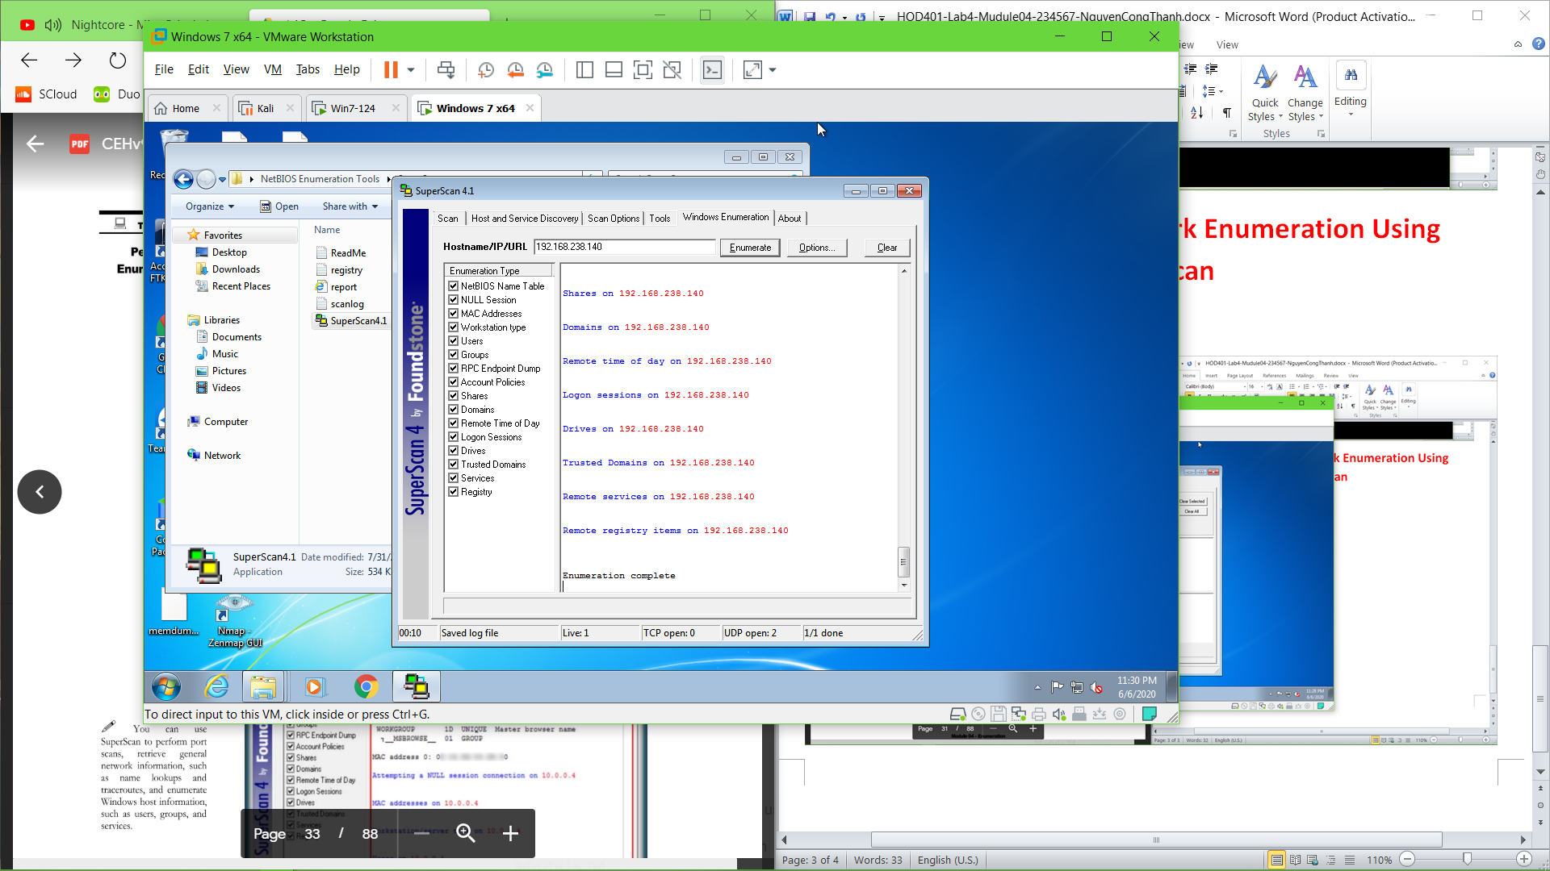

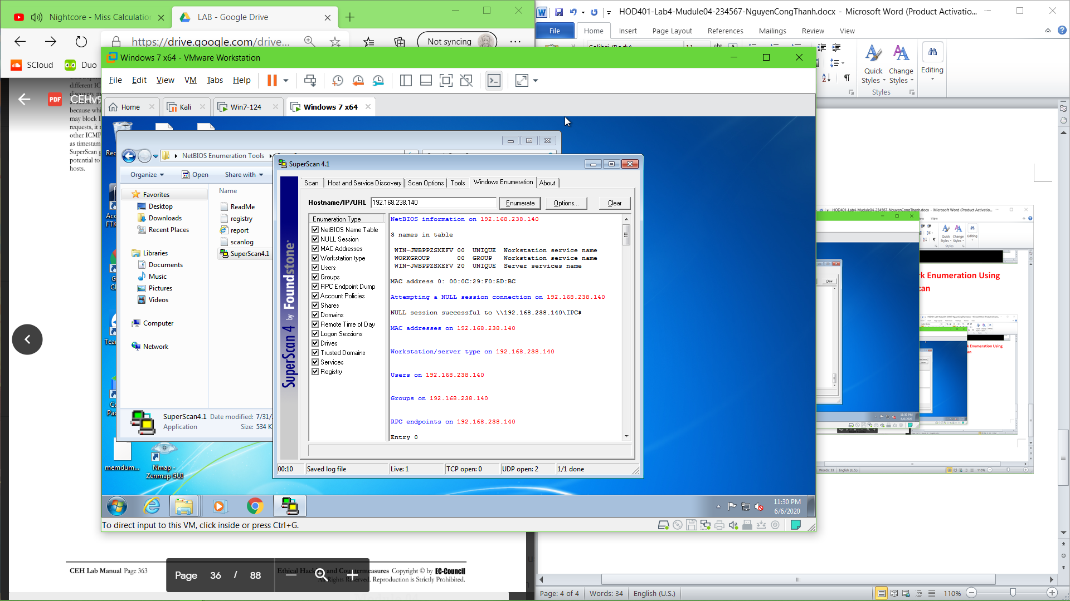

**Lab 4: Enumerating Resources in Local Machine Usinf Hyena**

**Install & run** 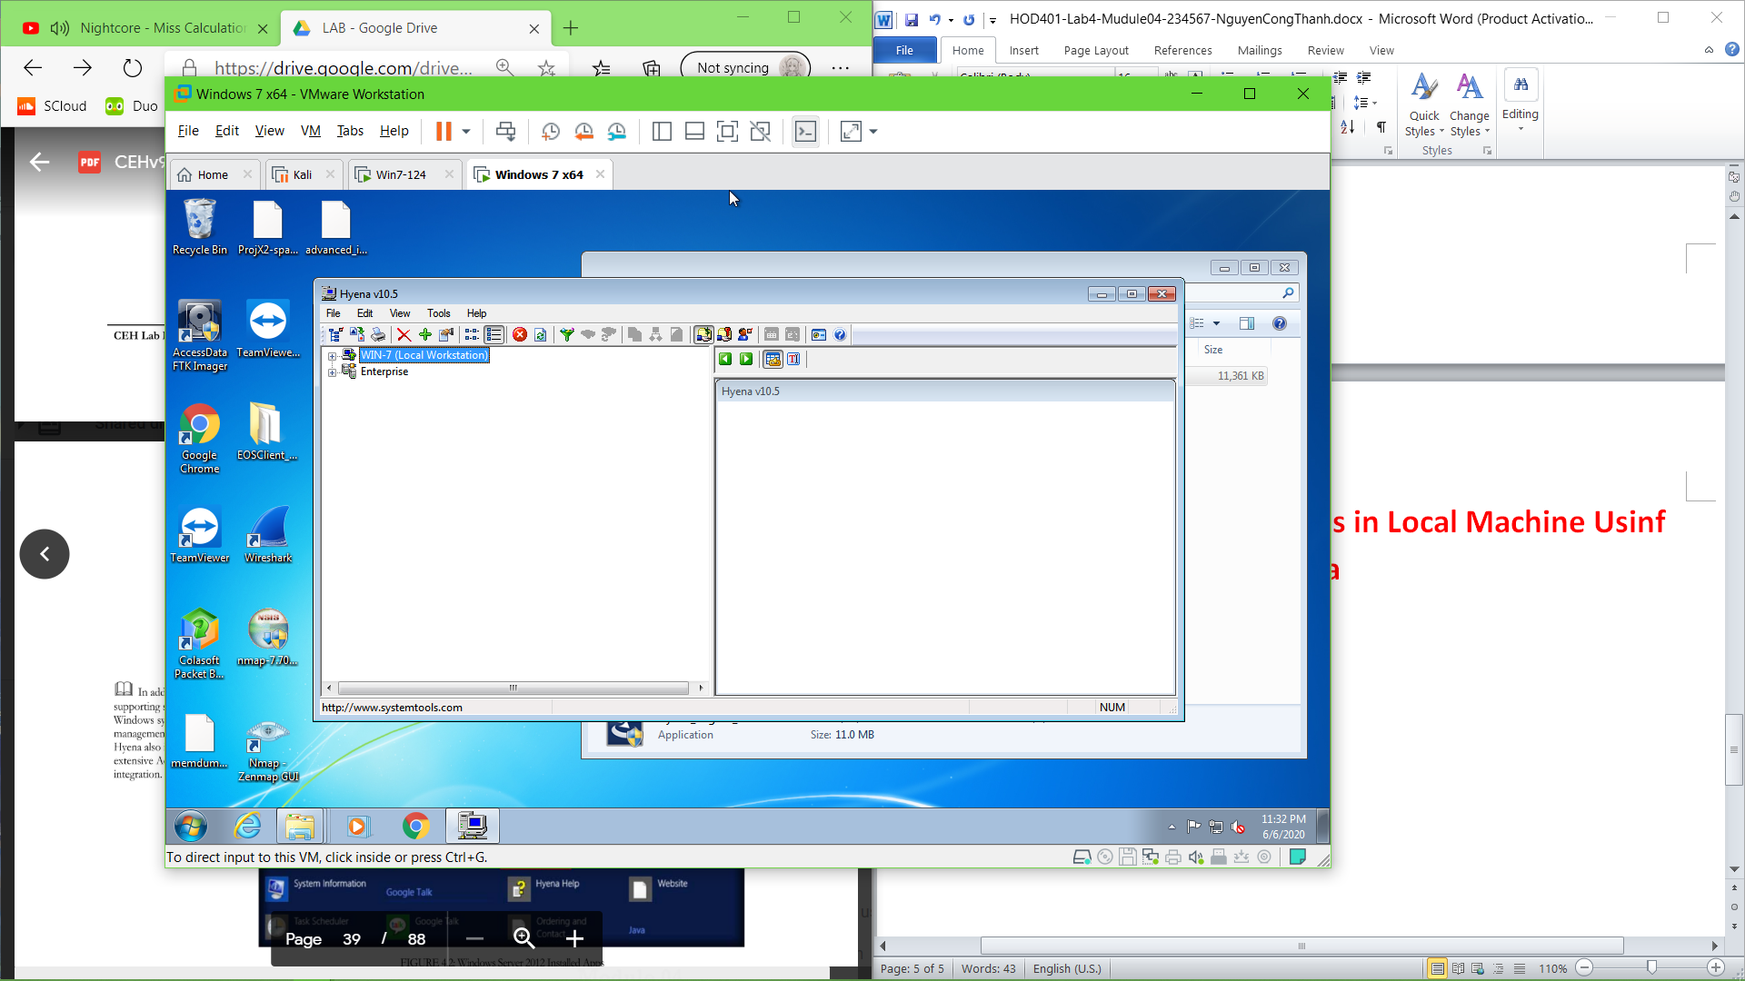

**Usr & Services** 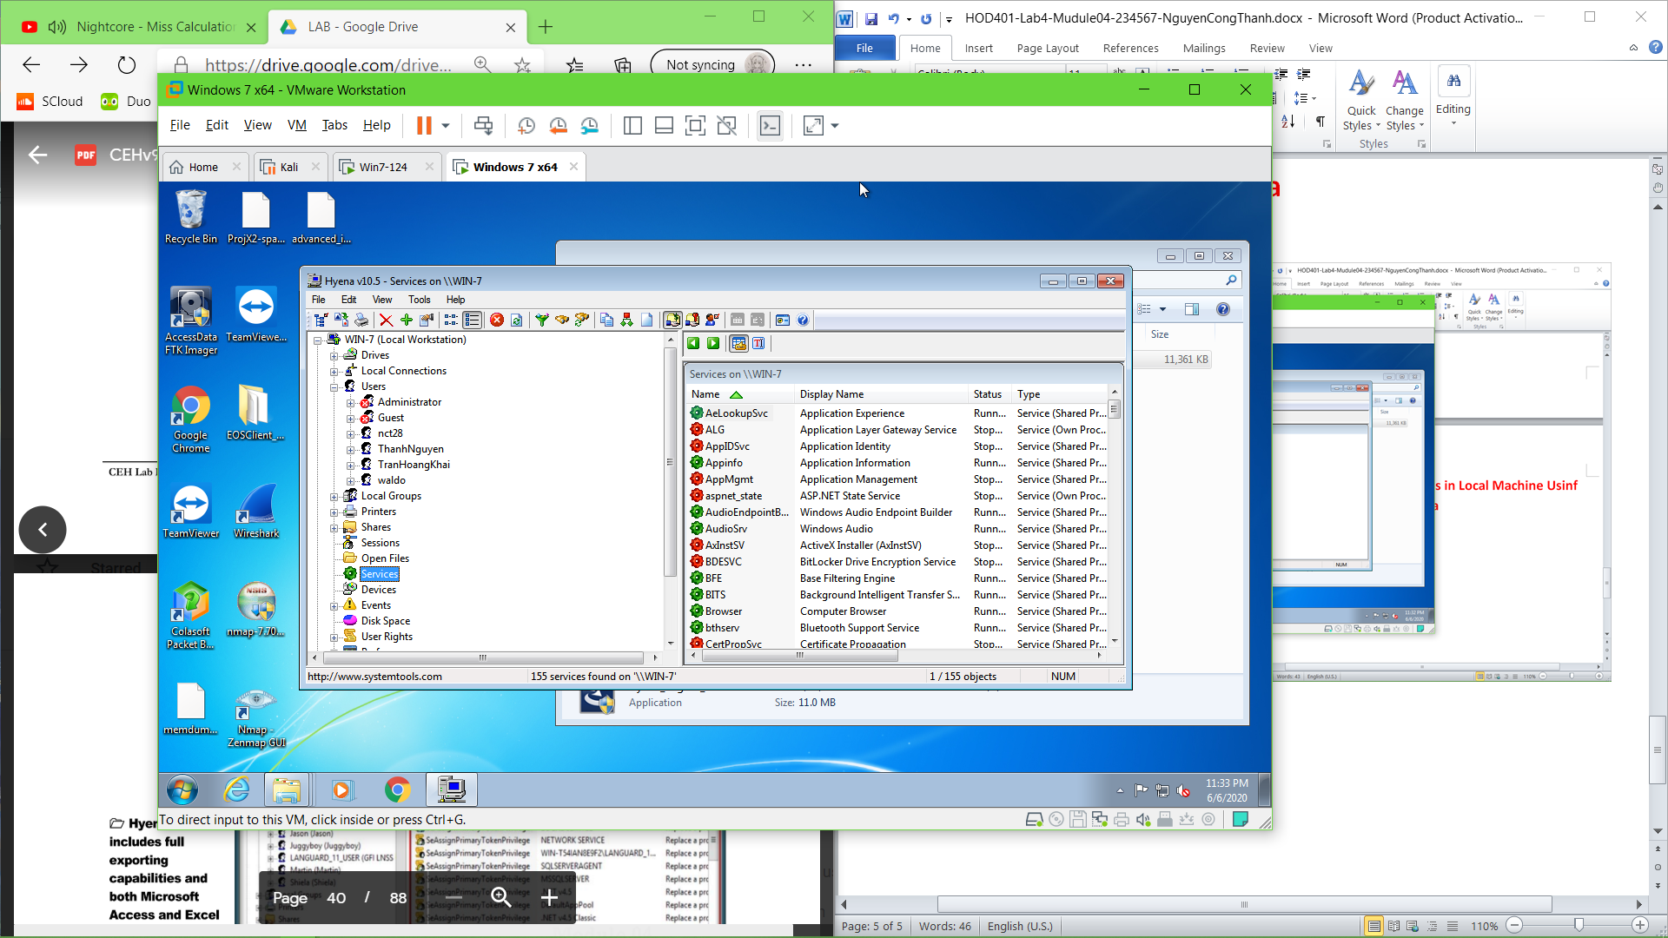

Usr Right 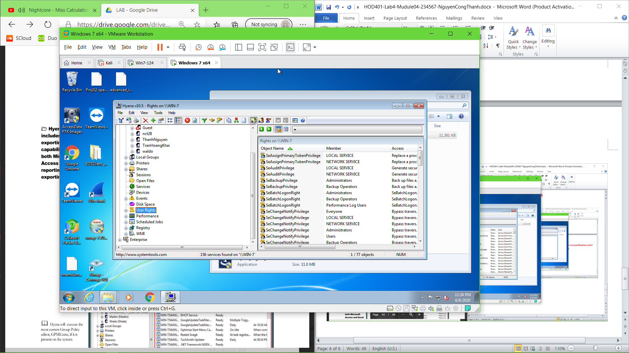

Scheduled jobs

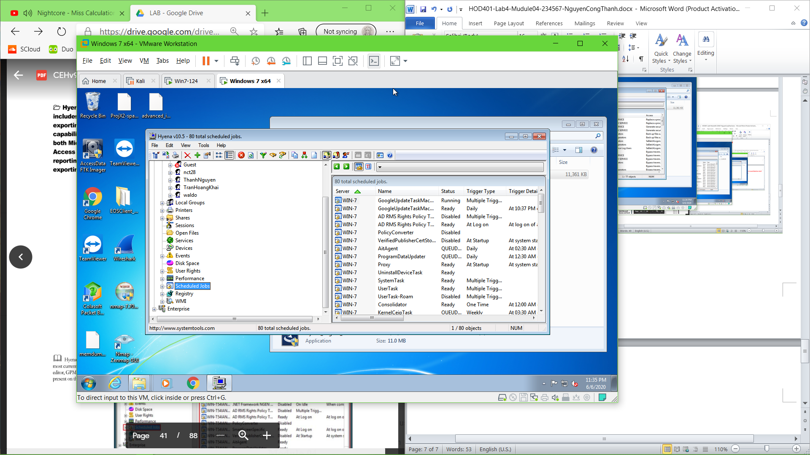

**Lab 5: Performing Network Enumeration Using NetBIOS Enumerator**

**Run a scan** 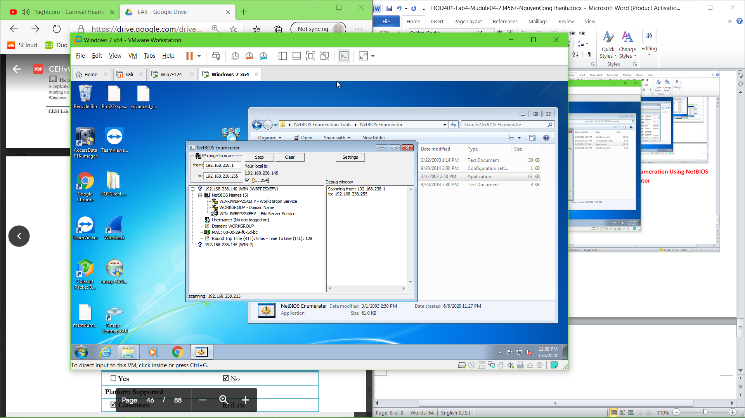

**Lab 6: Unemerationg a Network Using SoftPerfect Network Scanner**

Run a scan

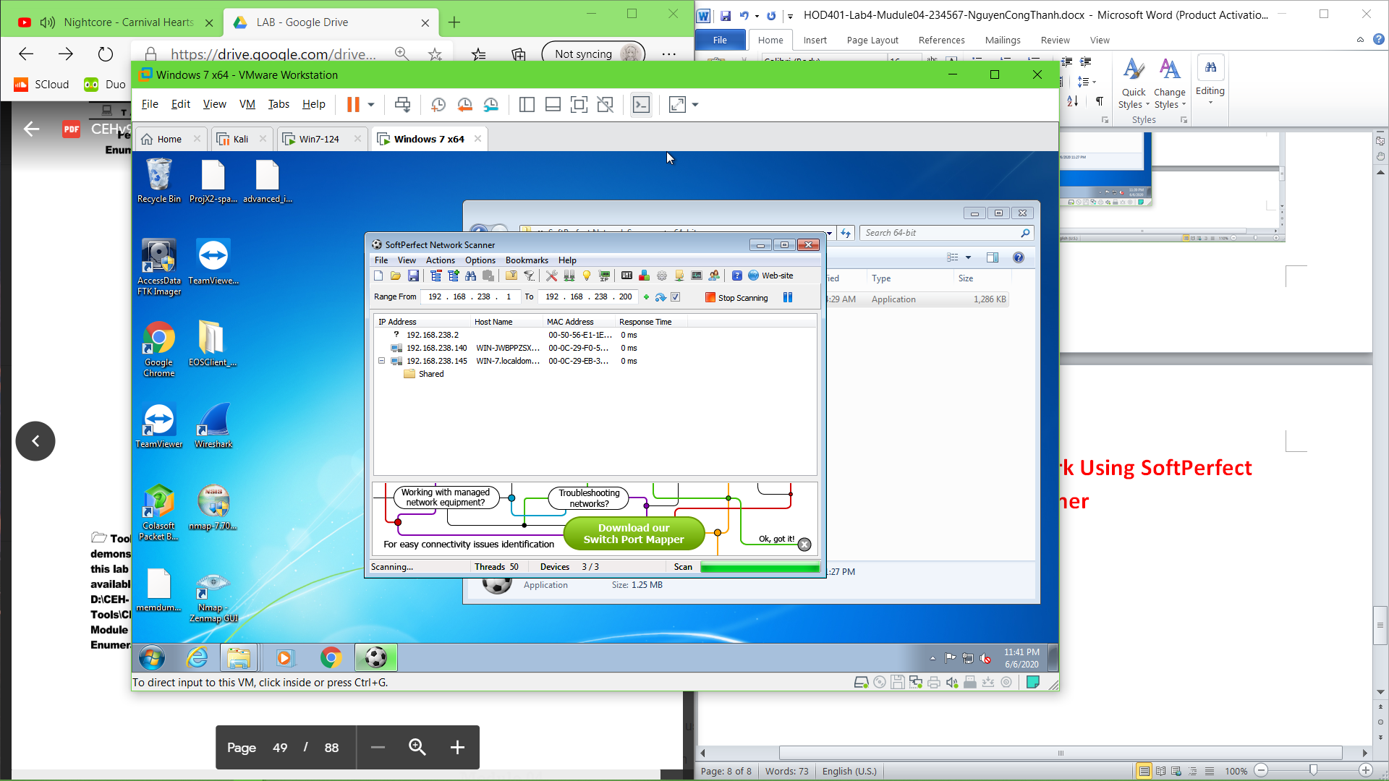

**Property** 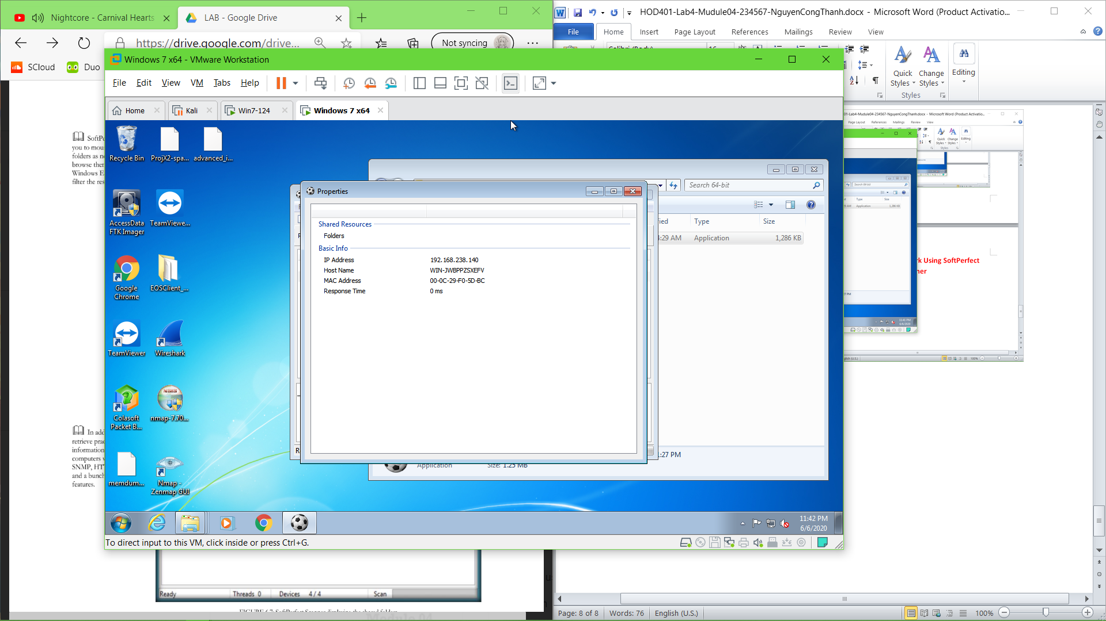

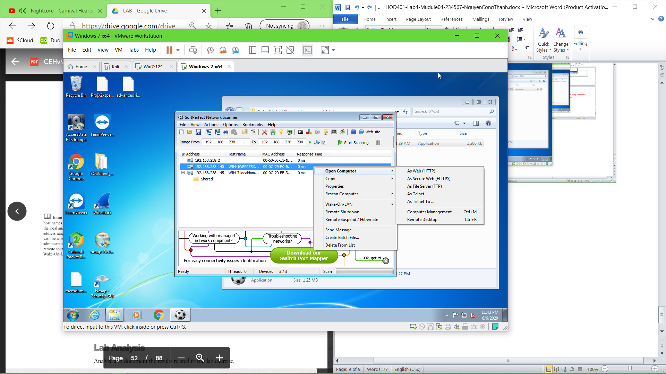

**Lab 7: Enumerrating a Target Network Using Nmap anf Net use**

**Run a scan Nmap on target**

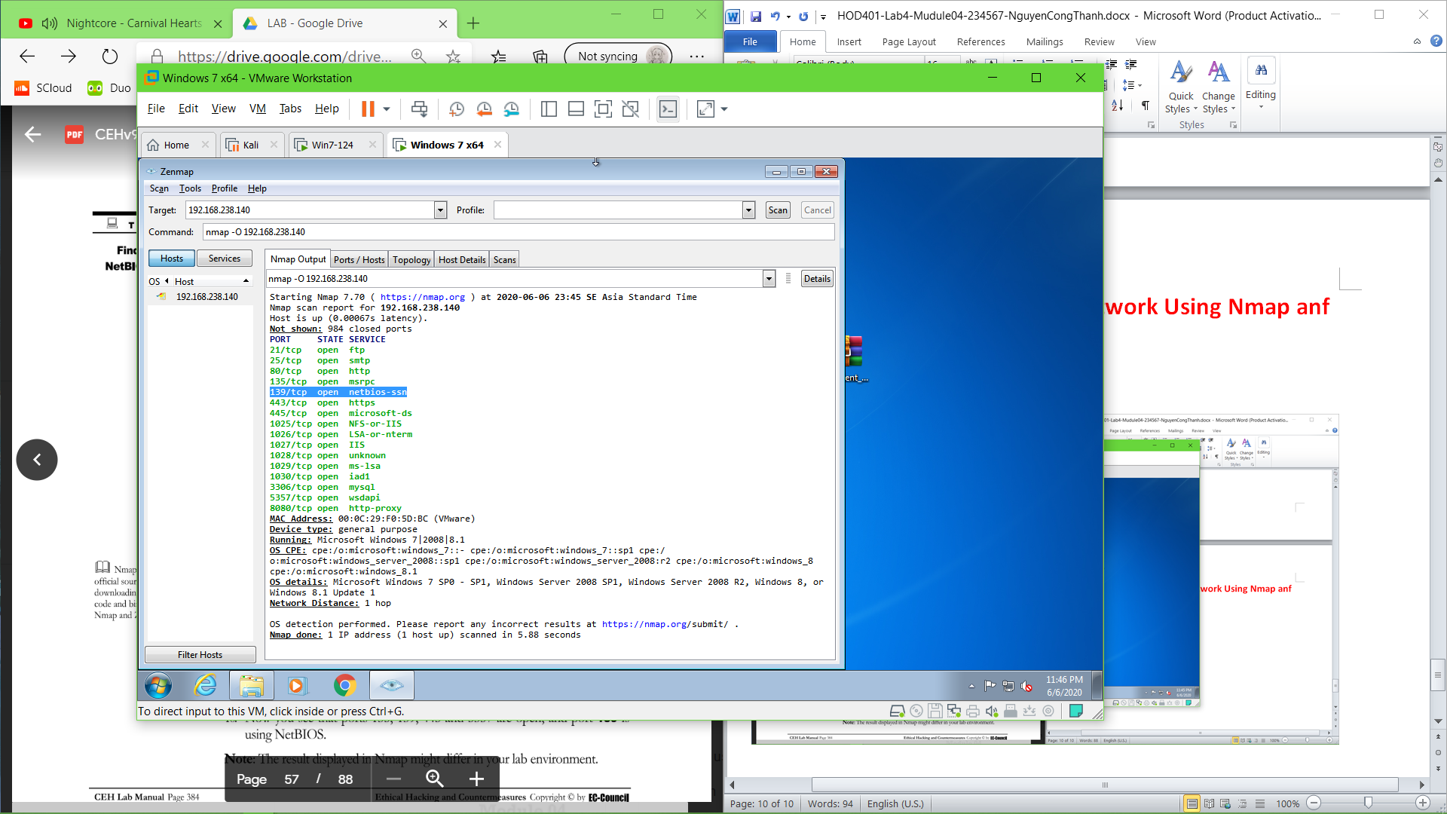

**Nbtstat –A 192.168.238.140**

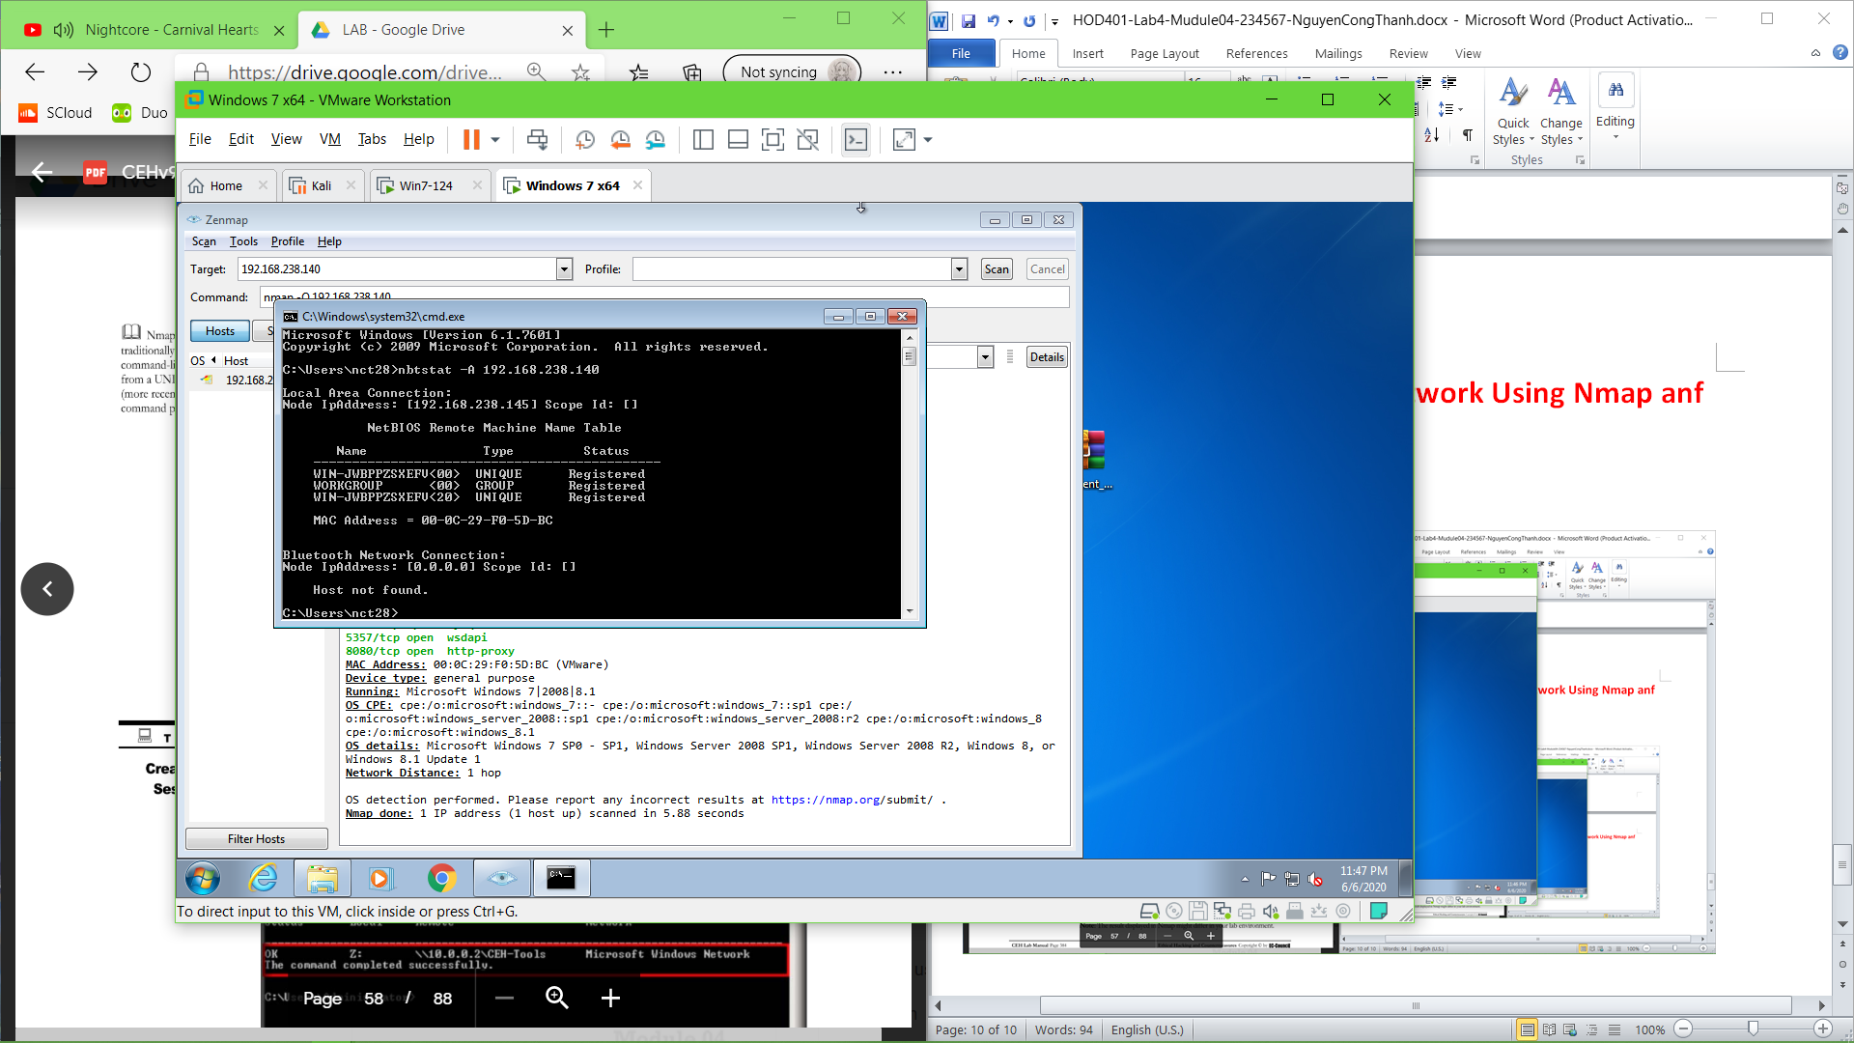

**Net use on local machine**

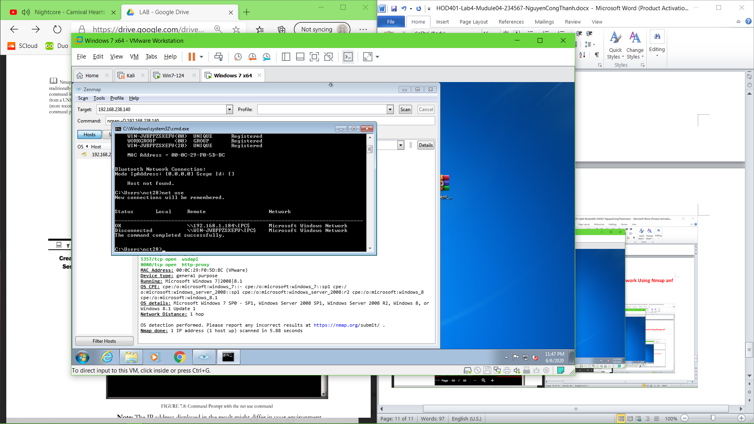

**Net use to target**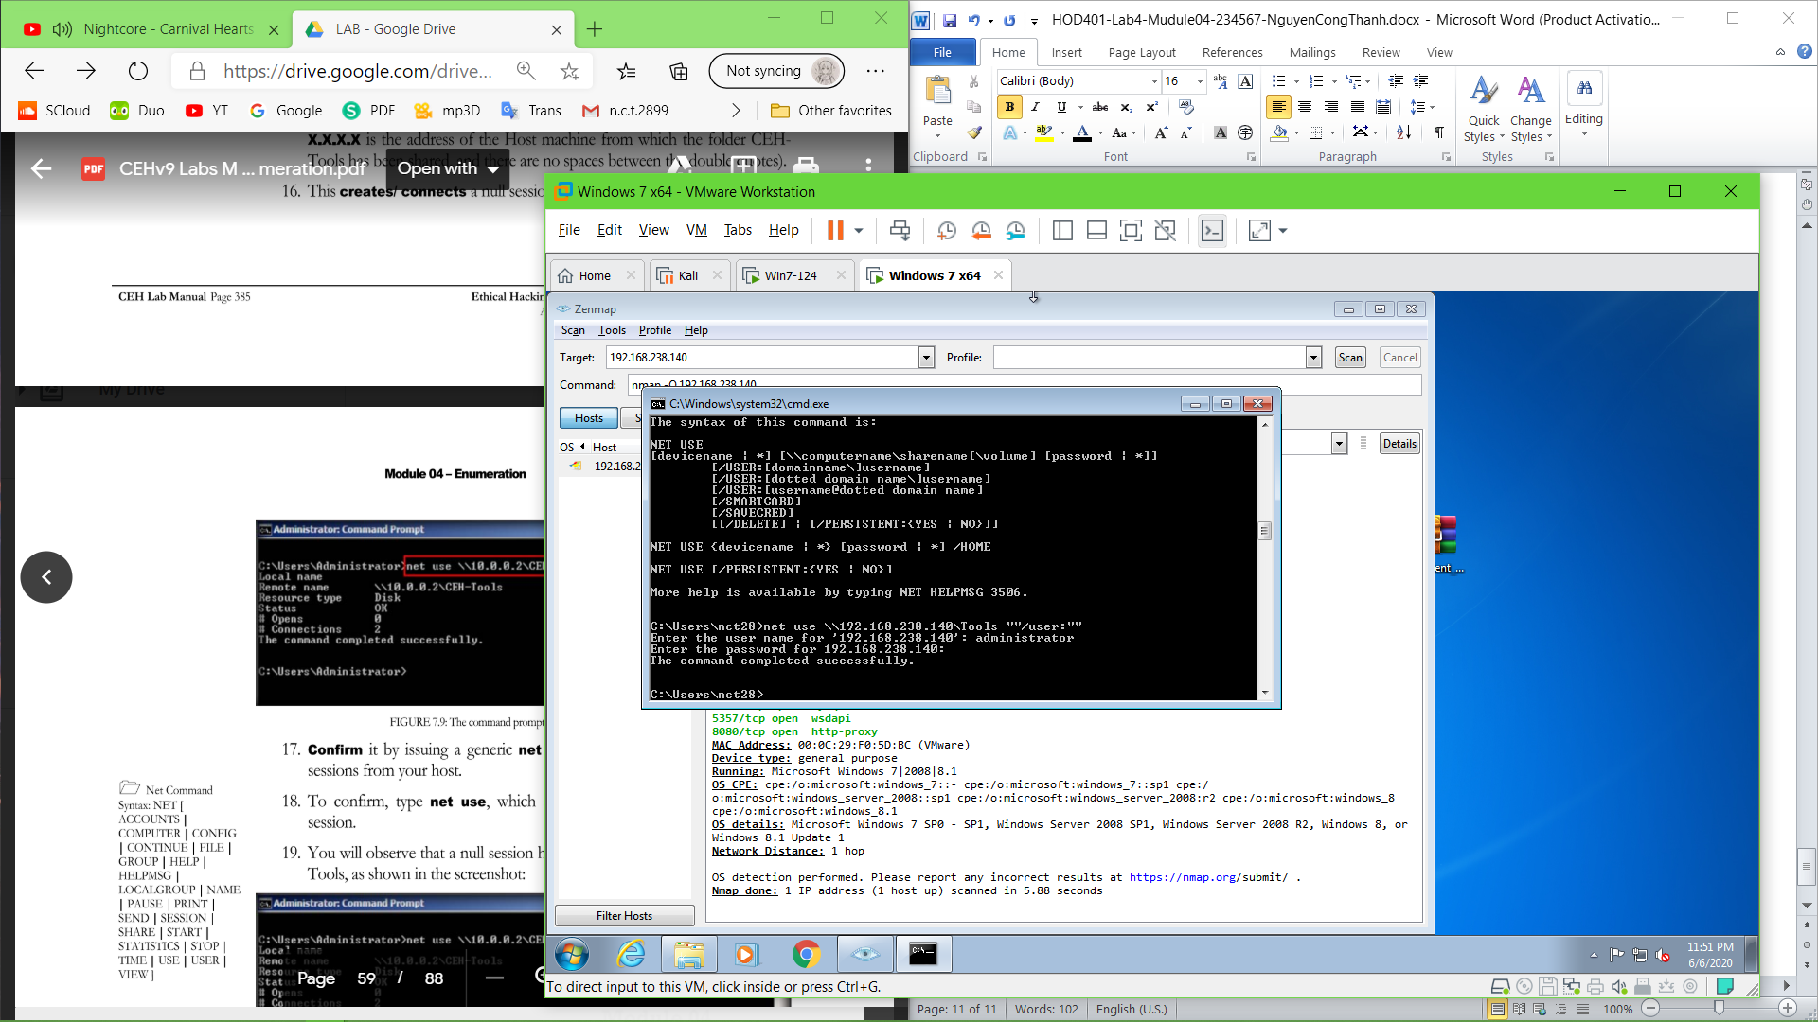

**Net use on local to see new remote apear**

